**DevOps Estimation for planning and development**

Automation project on DigitalOcean, taking into account variations based on Terraform modules and previous project experience:

**Time Estimation (DigitalOcean):**

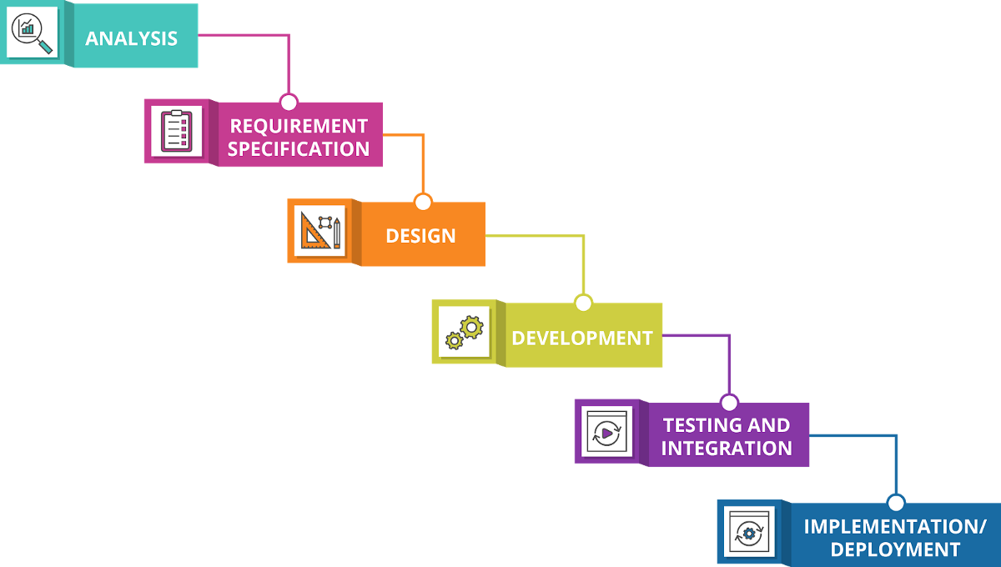

**Planning and Preparation (2-4 weeks):**

* + Define project objectives and scope.
  + Identify the specific tools and technologies to be used.
  + Set up DigitalOcean accounts and infrastructure.
  + Assemble the project team, if not already in place.
  + Hours: Approximately 80-160 hours. This time may vary based on the modules of Terraform. From 40 to 80 hours

**Development and Integration (4-6 weeks):**

* + Develop and configure the CI/CD pipeline.
  + Create or enhance the web application's codebase.
  + Implement code commits and triggers.
  + Integrate Docker for containerization.
  + Develop Ansible playbooks for configuration management.
  + Set up the monitoring and alerting system.

Hours: Approximately 160-240 hours.

**Testing and Quality Assurance (2-4 weeks):**

* + Test the CI/CD pipeline thoroughly.
  + Ensure proper integration between tools.
  + Conduct security testing and code quality checks.
  + Verify the accuracy of monitoring and alerting.
  + Hours: Approximately 80-160 hours.

**Deployment and Staging (2-4 weeks):**

* + Deploy the CI/CD pipeline to a staging environment on DigitalOcean.
  + Perform testing in a controlled environment.
  + Address any issues or bugs identified during staging.
  + Hours: Approximately 80-160 hours.

**Production Deployment (1-2 weeks):**

* + Deploy the CI/CD pipeline to the production environment on DigitalOcean.
  + Monitor the initial deployments closely for any issues.
  + Implement a rollback plan in case of unforeseen problems.
  + Hours: Approximately 40-80 hours.

**Optimization and Additional Goals (Varies):**

* + Fine-tune and optimize the CI/CD pipeline for efficiency.
  + Consider implementing optional goals like DevSecOps, Infrastructure as Code, or container orchestration based on available time and requirements.
  + Hours: Varies based on the complexity of additional goals.

**Documentation and Knowledge Transfer (2-3 weeks):**

* + Document the entire CI/CD pipeline setup and configuration.
  + Provide training or knowledge transfer to the team members who will maintain the system.
  + Hours: Approximately 80-120 hours.

**Ongoing Maintenance and Support (Continuous):**

* + Continuous monitoring and maintenance to ensure the system operates smoothly.
  + Handle updates, security patches, and any necessary improvements.
  + Hours: Ongoing, varies based on maintenance needs.

Please keep in mind that these are rough estimates, and the actual time required may vary depending on factors such as the complexity of your web application, the proficiency of your team, and any specific challenges encountered during the project. It's essential to track progress regularly and adjust the timeline as needed. Additionally, the hour estimates are based on a typical workweek of 40 hours, so you may need to adjust them if your team works different hours per week.

**Hourly rate $20**

